Project Design Phase-II
Technology Stack (Architecture & Stack)

Date | 27 June 2025
Team ID | LTVIP2025TMID53093
Project Name | HouseHunt : Finding your perfect rental Home
Maximum Marks | 4 Marks

Technical Architecture – HouseHunt
HouseHunt is built using a client-server architecture, ensuring smooth interaction between users, agents, and admins. The system is divided into three main layers: Frontend, Backend, and Database. RESTful APIs connect the layers, enabling secure and efficient data exchange. Real-time chat and notifications are supported using Socket.IO.
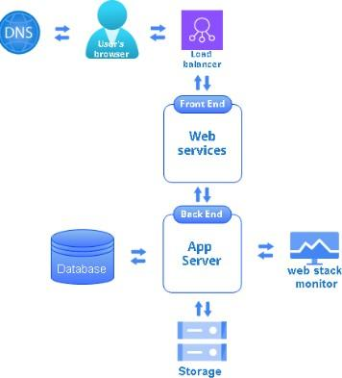

Architecture Guidelines – HouseHunt

- The system includes core blocks:
- Frontend: React.js (Material UI, Bootstrap)
- Backend: Node.js + Express.js (REST APIs)
- Database: MongoDB (User, Complaint, Chat, Feedback data)
- Infrastructure:
  - Local setup for development
  - Cloud deployment via Vercel (frontend), Render or Railway (backend), MongoDB Atlas (database)
- External Interfaces:
  - Gmail SMTP for emails
  - Google OAuth for login
  - Optional: Twilio for SMS
- Data Storage:
  - All structured data in MongoDB
  - Files/images stored via Firebase or AWS S3 (optional)
- ML Model (Optional):
- Future-ready for smart routing or auto-prioritization using ML

Table-1: Components & Technologies

S.No | Component | Description | Technology
1 | User Interface | How user interacts with the application (Web UI, etc.) | React.js, HTML, CSS, JavaScript, Material UI, Bootstrap
2 | Backend | Server-side logic, API routes, authentication, CRUD operations | Node.js, Express.js
3 | Authentication | Handles user login, registration, and JWT-based session contro | JSON Web Token (JWT)
4 | API Testing | Testing API endpoints manually during development | Postman
5 | Database | Data storage for users, complaints, chats, etc. | MongoDB (NoSQL)
6 | State Management | Handling local component state and API response handling | React useState, useEffect, Axios
7 | Image Upload | Uploading and saving property images to server | Multer (Node middleware)
8 | Routing | Navigating between pages in frontend | React Router DOM
9 | Admin Panel | Admin functionalities like owner approval | Custom-built React Components
10 | Infrastructure | Hosting backend/frontend on cloud/local | Localhost, Render, Railway, Cloud Foundry, Kubernetes

Table-2: Application Characteristics

S.No | Characteristics | Description | Technology Used
1 | Open-Source Frameworks | Libraries and frameworks used | React.js, Express.js, Node.js, Mongoose, Socket.io
2 | Security Implementations | Authentication, Authorization, Data Protection | JWT, bcrypt.js, CORS, HTTPS, SHA-256, Helmet
3 | Scalable Architecture | Modular design for performance and growth | 3-tier architecture, Microservices-ready, REST APIs
4 | Availability | Ensures uptime, handles traffic | Load Balancers, Cloud Deployment, Clustered MongoDB
5 | Performance | Optimized code for response time and user experience | Axios, CDN, Caching (Redis optional), Lazy Loading

References

- C4 Model for Visualising Software Architecture. Retrieved from: https://c4model.com/
- IBM Developer: Online Order Processing System During Pandemic. Retrieved from: https://developer.ibm.com/patterns/online-order- processing-system-during-pandemic/
- IBM Cloud Architecture Center. Retrieved from: https://www.ibm.com/cloud/architecture
- AWS Architecture Center. Retrieved from: https://aws.amazon.com/architecture
- “How to Draw Useful Technical Architecture Diagrams” – Medium Article. Retrieved from: https://medium.com/the-internal-startup/how-to- draw-useful-technical-architecture-diagrams-2d20c9fda90d

